Using firewall to allow or deny incoming or outgoing traffic between windows and linux.

From the terminal shell for windows, run the command prompt and execute ipconfig to get the IP address.

From the command prompt for kali, execute ifconfig to get the ip address

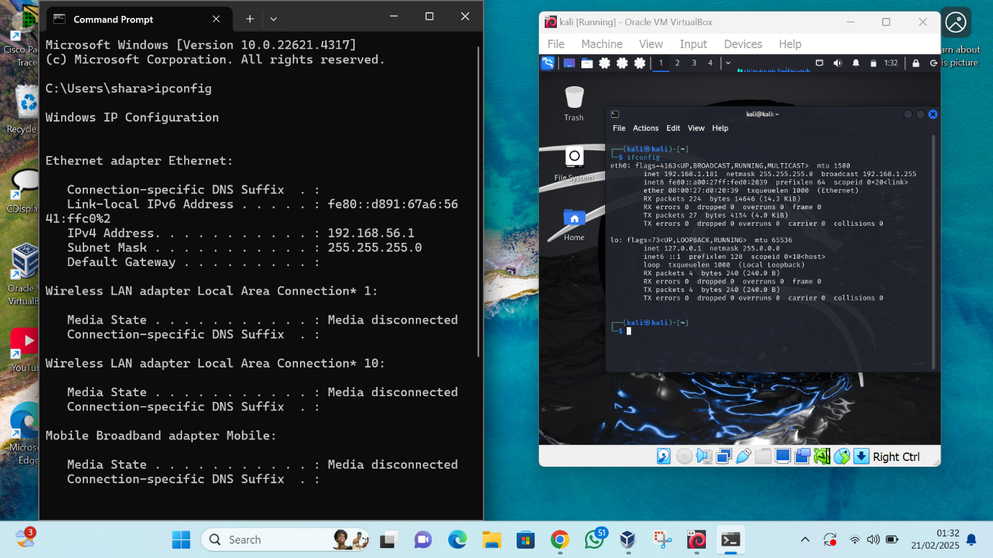

From the windows, run a command to ping the linux which was successful

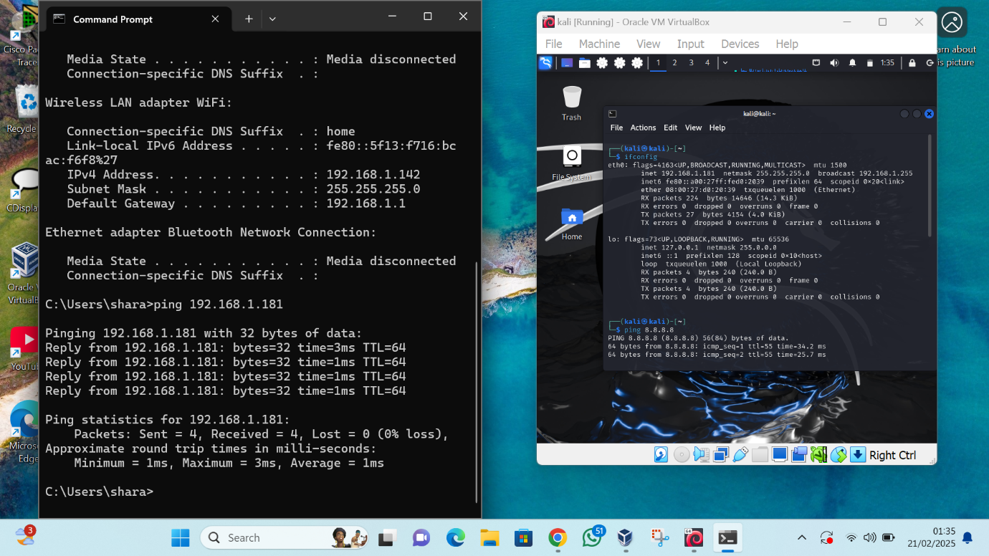

From the linux, run a command to ping the windows which failed

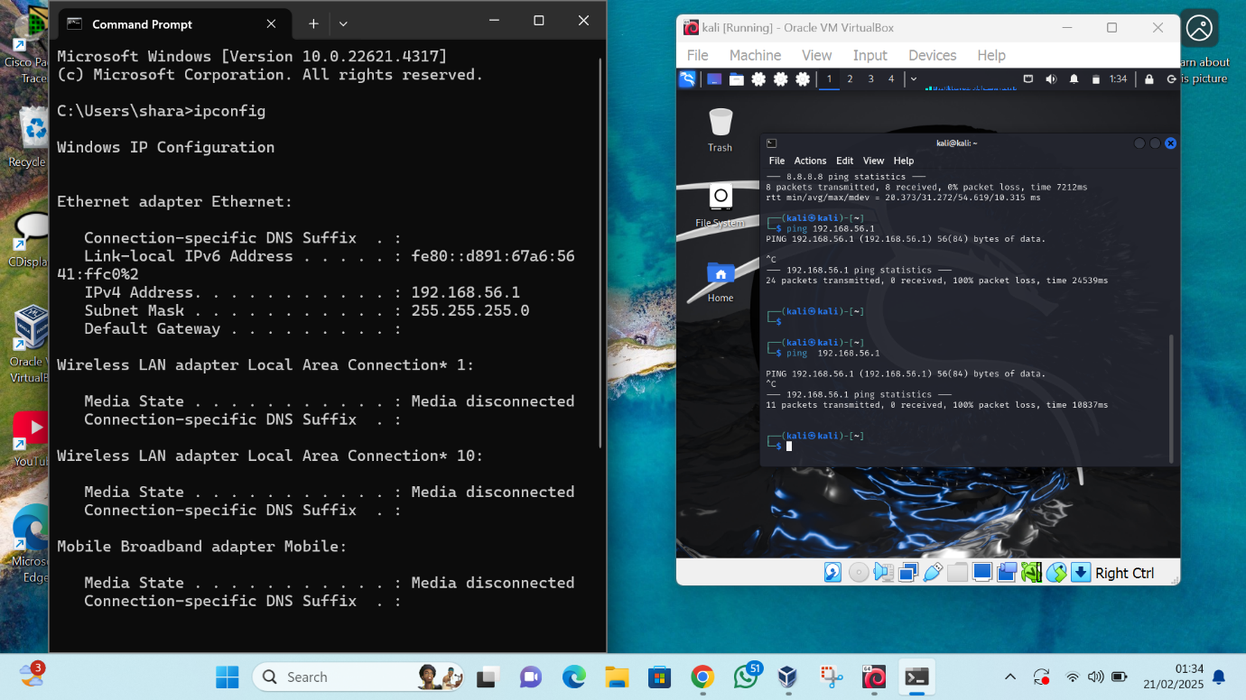

So an inbound rule will be written to allow this.

Open the windows defender firewall and click advanced settings then select inbound rule.

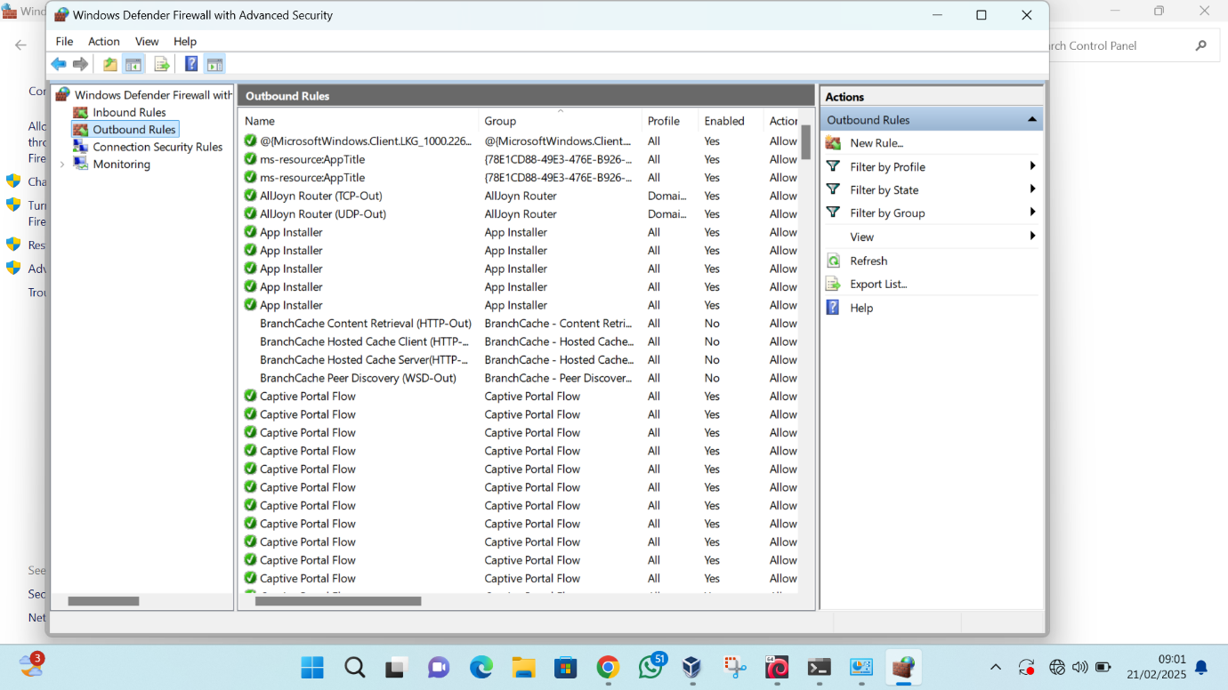

To write a new rule, click on the new rule option on your right, select custom and choose all programs.

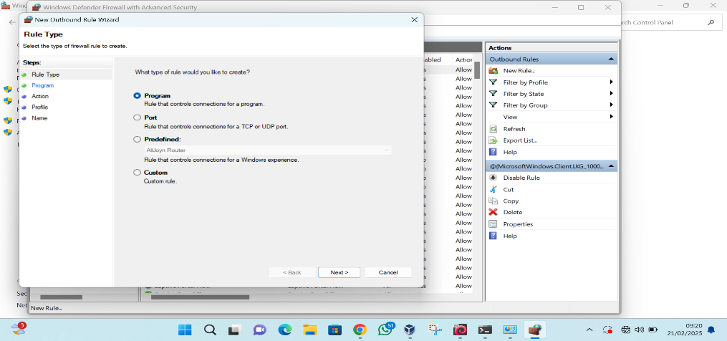

For protocol type, choose “any”, it will then require the IP address, you can input specific ip address or use any

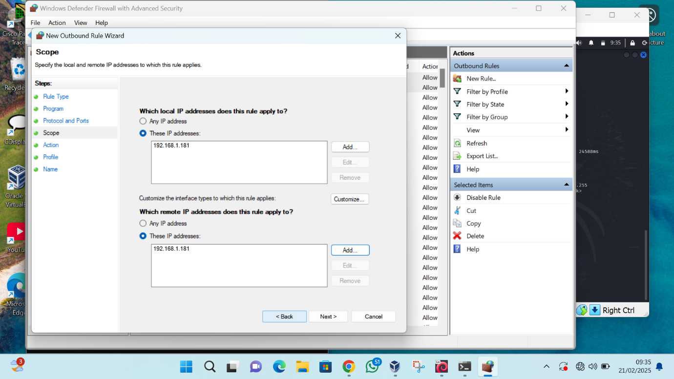

Then allow the connections

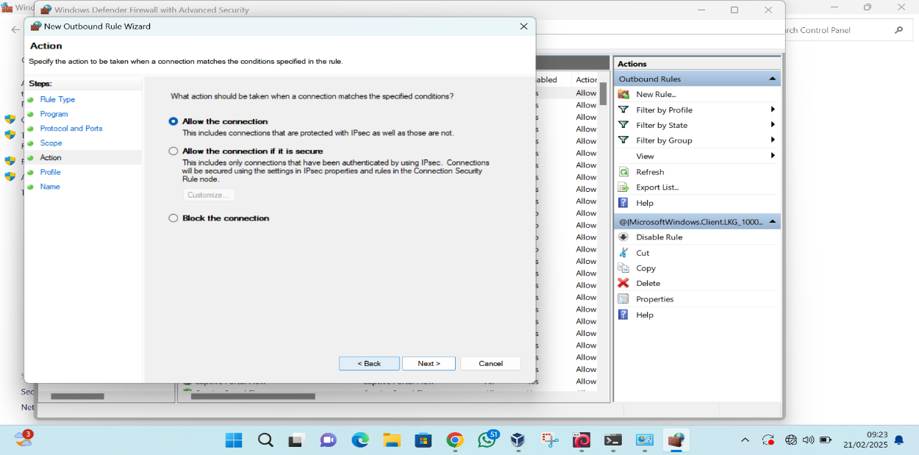

Then select the profile it should apply to

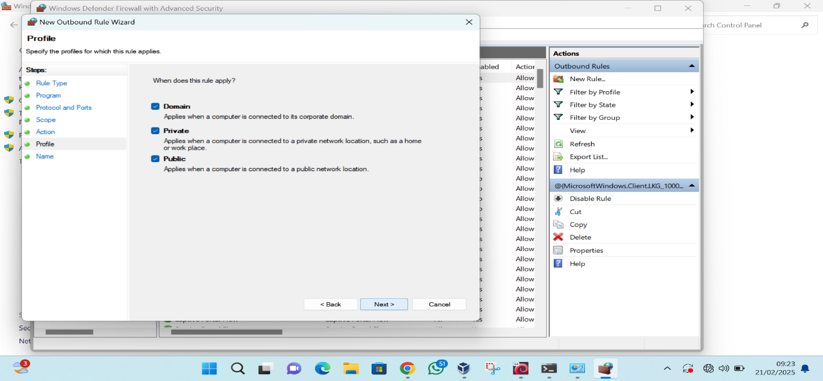

Afterwhich you will chose a name for the rule and save it

The new rule will appear on the list of inbound rule and now the windows and now the windows can ping the kali.

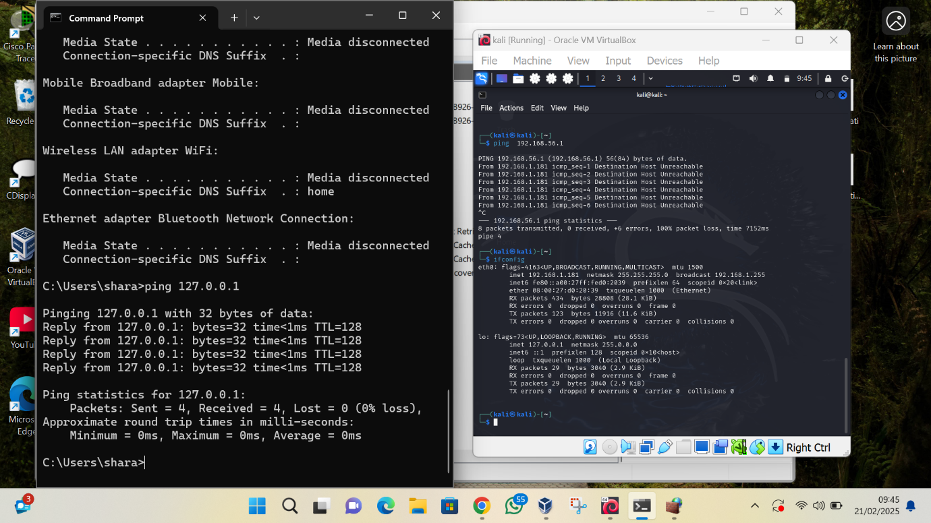

Similar steps are taken to write an outbound rule.

The steps are also similar to block connection but block the connection will be selected instead of allow all connection, Then it becomes impossible to ping the linux.

